**Project Development Phase**

**Delivery of Sprint – 4**

|  |  |
| --- | --- |
| **Date** | **14 November 2022** |
| **Team ID** | **PNT2022TMID45108** |
| **Project Name** | **AI based discourse for Banking Industry** |

# Creating Assistant & Integrate With Flask Web Page

Let us build our flask application which will be running in our local browser as an user interface.

In the flask application, users will interact with the chat bot, and based on the user queries they will get the chatbot responses.

# Building Python Code

## 1: Importing Libraries

The first step is usually importing the libraries that will be needed in the program.

from flask import Flask,render_template

Importing the flask module into the project is mandatory. An object of the Flask class is our WSGI application. Flask constructor takes the name of the current module ( name ).

## 2: Creating our flask application and loading

|  |
| --- |
| ) |

app = Flask(name

## 3: Routing to the Html Page

Here, the declared constructor is used to route to the HTML page created earlier.

The ‘/’ route is bound with the bot function. Hence, when the home page of a web server is opened in the browser, the HTML page will be rendered.

|  |
| --- |
| @app.route('/Chatbot', methods = ['GET','POST']) |
| defChatbot():  return render_template('Chatbot.html') |

## Main Function

This is used to run the application in local host.

|  |  |
| --- | --- |
| if name  app.run() | == 'main': |

# Building HTML Code

We have used HTML to create the front-end part of the web page.

Here, we have created“index.html” displays the home page which gets integrated with Watson Assistant.

Auto-generated source code which contains the Integration ID of IBM Watson Assistants is copied and pasted inside the body tag.

## Run the application

1. Open Vs Code
2. Navigate to the folder where app.py resides.

3.Run the python code

1. Open a browser and type this URLhttp://127.0.0.1:5500/.
2. Click Chatbot.html and then it shows http://127.0.0.1:5500/Chatbot.html

6.It launches the application integrated with IBM Watson Assistant.

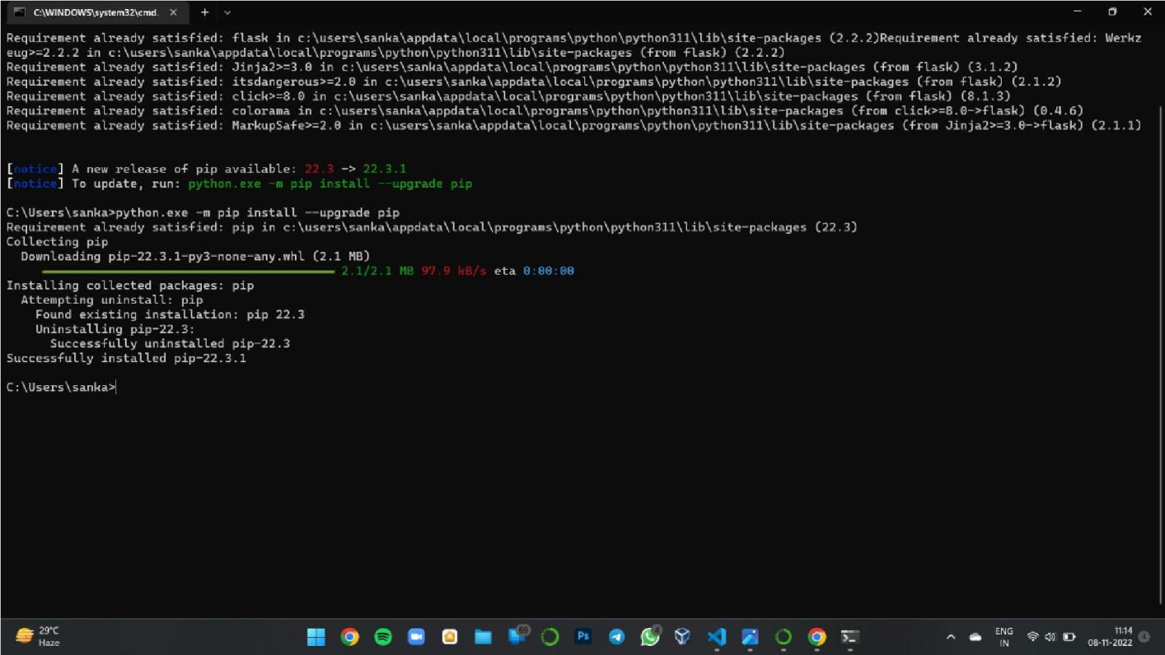

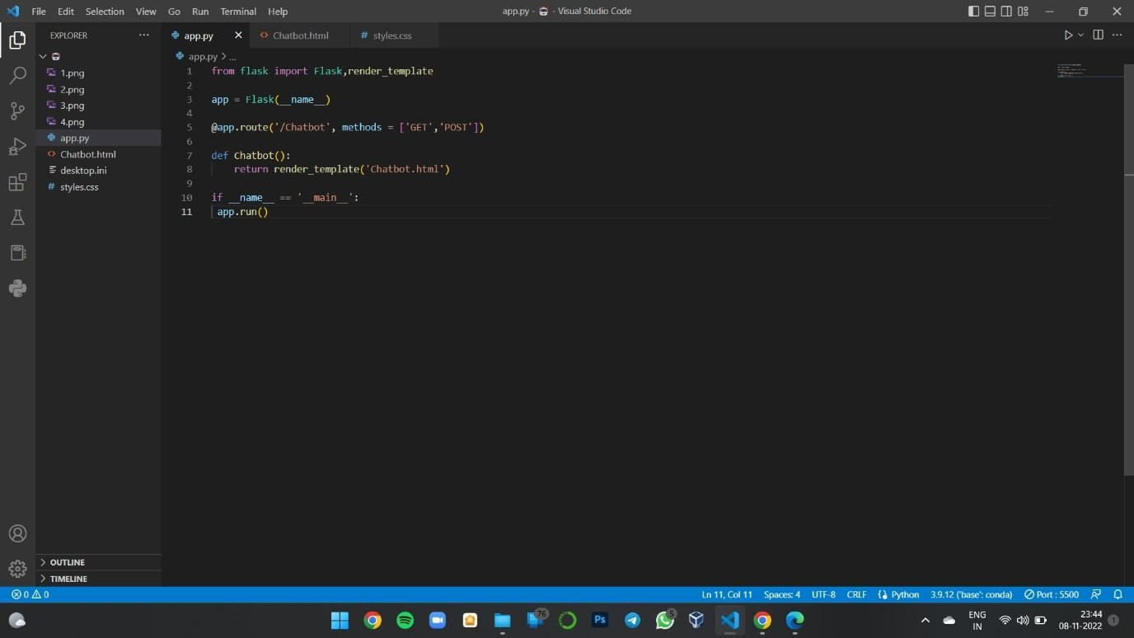

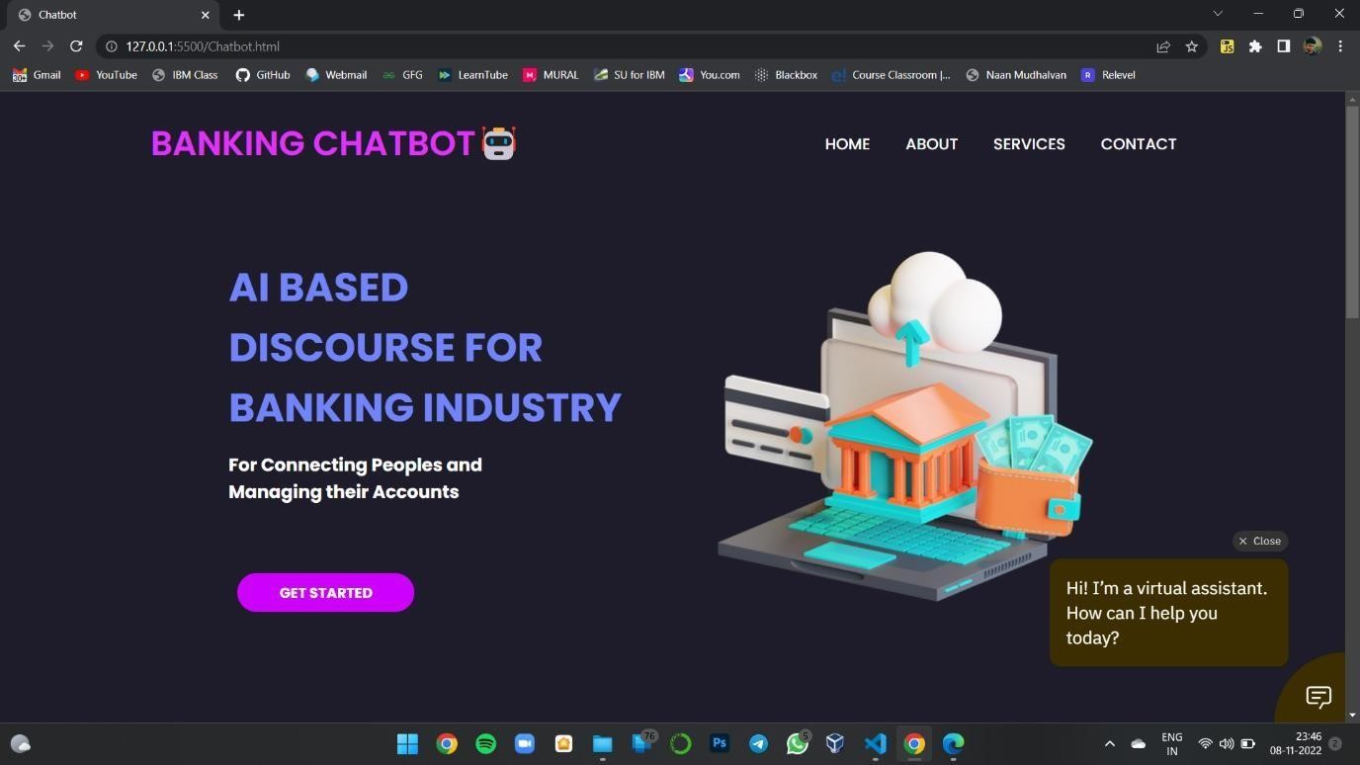

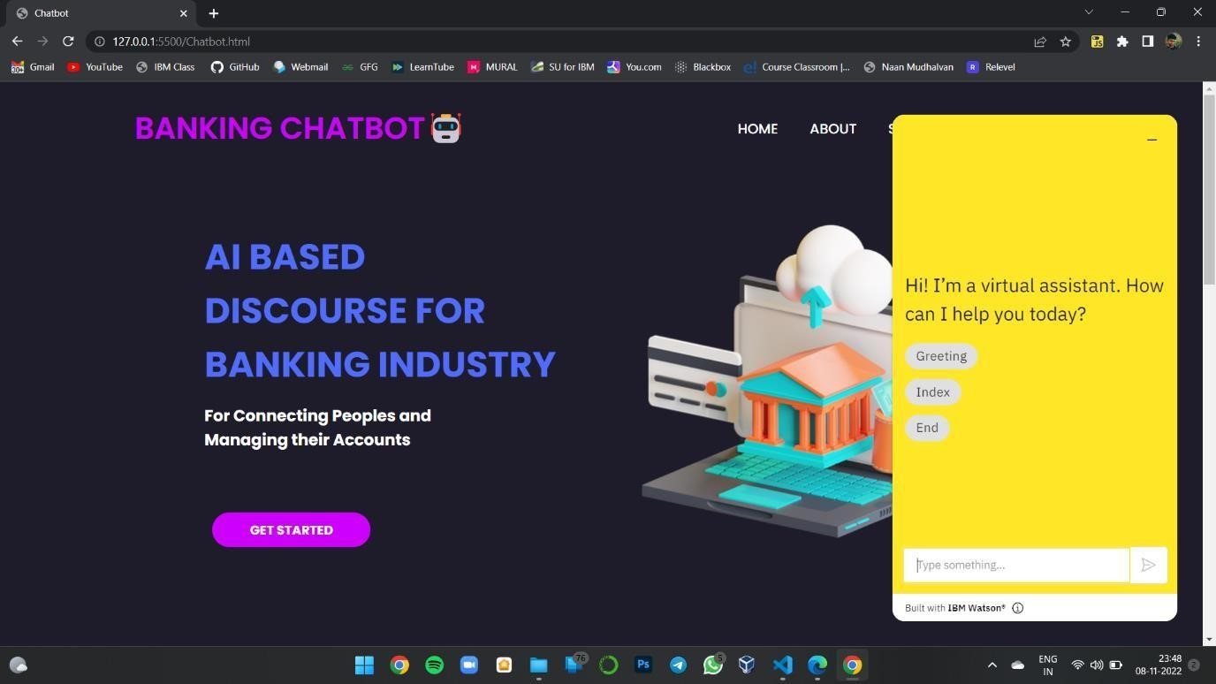

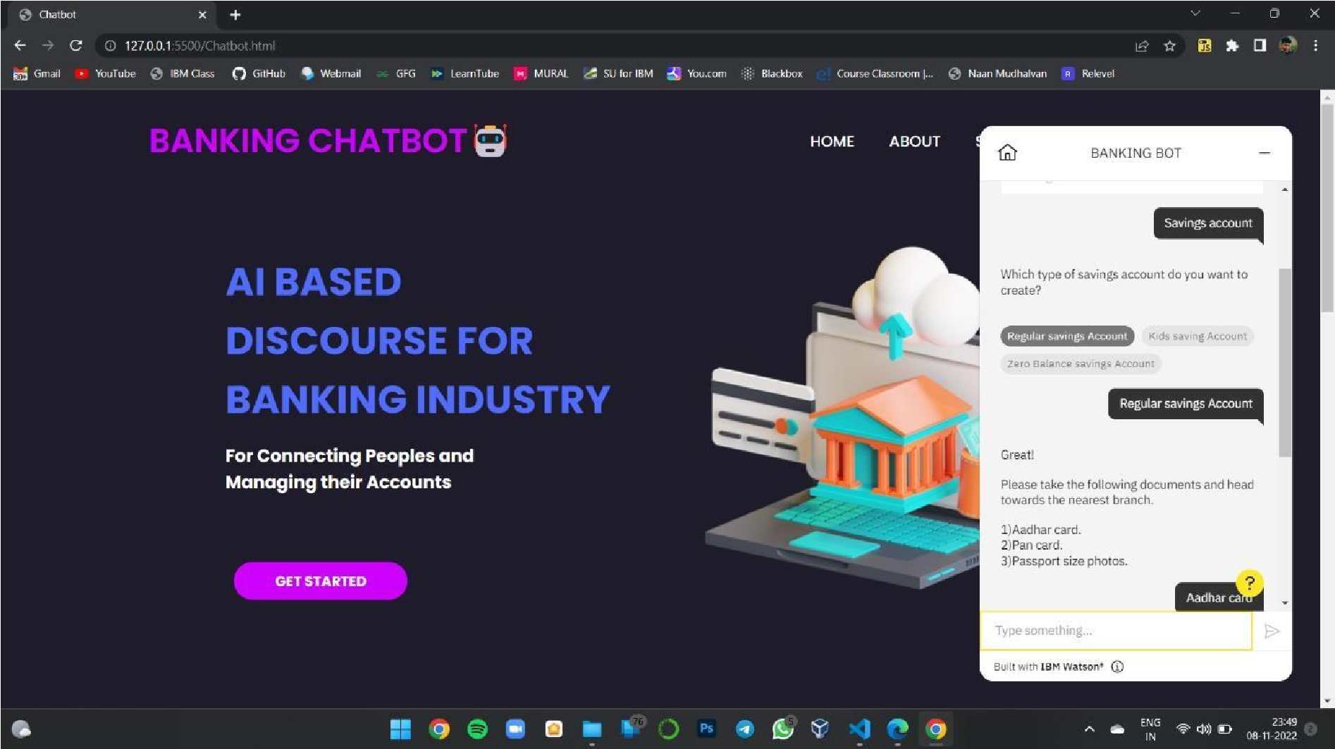

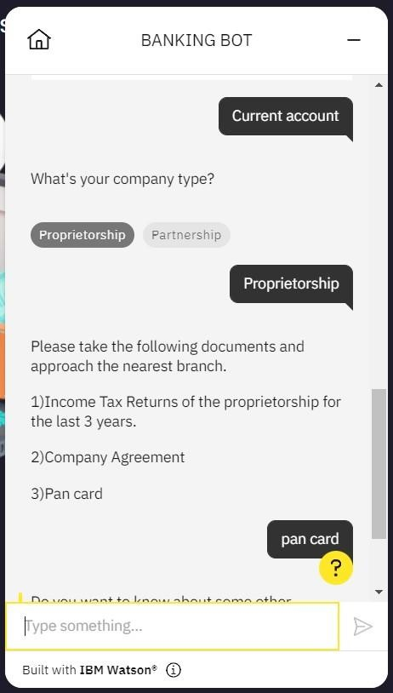

**Preview of Chatbot**

## https://webchat.global.assistant.watson.appdomain.cloud/preview.html?backgroundImageURL=https%3A%2F%2Fus-south.assistant.watson.cloud.ibm.com%2Fpublic%2Fimages%2Fupx-3533978938d5-451f-8f05-3ddb5dbbe57e%3A%3A49d7f8d1-0500-4610-9518-068ec885f252&integrationID=fc789460-2e93-472d-b324-c85bef5219f5&region=us-south&serviceInstanceID=35339789-38d5-451f-8f05-3ddb5dbbe57e

**Source code is attached in Final Deliverables.**

**Note**: No code for this project. So, I attached the screenshot and step to build it.